DECLARATION
I hereby declare that the project titled “Online Grocery E-Commerce Website” submitted by me is an original work carried out under the guidance of my project guide. This project report has not been submitted to any other university or institution for the award of any degree or MASTER OF COMPUTER APPLICATION
I further declare that all the information and data presented in this report are true to the best of my knowledge. Wherever references have been made to the work of others, it has been clearly acknowledged.

Date: 22/04/2026

Prof. Hardi Patel Prof. Prashant Vaghela Project In Charge(Exam Coordination) Director(I/c)

ACKNOWLEDGMENT
We would like to express our heartfelt gratitude to our guide, Mrs. Hardi Patel, Assistant Professor, MCA Department, CTI, for her invaluable guidance, encouragement, and constructive feedback throughout the course of this project. Her expertise in the field of Machine Learning and her constant support helped us not only in shaping the technical aspects of the project but also in improving our analytical and problem-solving skills.
We are also thankful to the faculty members of the MCA Department for their insightful suggestions and encouragement, which motivated us to explore this topic in greater depth. Their academic guidance has been a source of inspiration and has greatly enriched our learning experience.
We are highly indebted to Mr. Prashant Vaghela director of a Chaudhary Technical Institute for allowing us to develop “Greencart – Cosmetics Ecommerce Website” for our research project.
We would also like to extend our appreciation to our peers and classmates, who provided us with valuable discussions, feedback, and moral support during the project journey. Their collaborative spirit fostered a positive and motivating environment.
Lastly, we are deeply grateful to our families for their patience, encouragement, and unwavering support. Their constant motivation and understanding helped us stay focused and complete this work with dedication.

Abstract
The rapid growth of digital technology has transformed the way people shop for daily necessities. This project presents the development of an e-commerce website for a grocery store that allows users to purchase essential items online in a convenient and efficient manner. The platform is designed to simplify the traditional shopping process by providing a user-friendly interface, secure transactions and doorstep delivery services.
The system enables users to browse a wide range of grocery products, add items to a shopping cart, and place orders seamlessly. It also includes features such as user authentication, product categorization, search functionality, and order management. On the admin side, the system provides controls to manage products, inventory, and customer orders effectively.
The main objective of this project is to create a responsive and easy-to-use web application that enhances user experience while reducing the time and effort required for grocery shopping. The project is developed using modern web technologies, ensuring scalability and performance.
Overall, this system aims to provide a reliable and efficient solution for online grocery shopping, benefiting both customers and store administrators.

Introduction.

With the advancement of internet technology, online shopping has become an essential part of modern life. People prefer digital platforms to purchase daily necessities due to their convenience, time-saving nature, and ease of access. Grocery shopping, which is a regular and necessary activity, can be made more efficient through an online system.

This project focuses on developing an e-commerce grocery website that allows users to browse, select, and purchase grocery items from the comfort of their homes. The system is designed to provide a smooth and user-friendly experience, making it easy for customers to find products, compare prices, and place orders quickly.

The platform includes various functionalities such as user registration and login, product listing, search and filtering, shopping cart management, and secure checkout. It also provides an admin panel for managing products, tracking orders, and maintaining inventory.

The main purpose of this project is to bridge the gap between traditional grocery shopping and modern digital solutions. It helps users save time, avoid long queues, and access a wide range of products in one place. Additionally, it benefits store owners by expanding their reach and Existing Systemimproving operational efficiency

Problem Statement
- Grocery shopping is a basic and recurring need for every household. However, the traditional method of purchasing groceries from physical stores involves several challenges such as time consumption, long queues, limited store hours, and lack of product availability. These issues become more significant for working individuals, students, and elderly people who may not have the time or ability to visit stores frequently.
- Moreover, many small and medium grocery businesses do not have an online presence, which limits their ability to reach a wider customer base. The absence of a proper digital system also makes it difficult to manage inventory, track orders, and maintain customer records efficiently.
- In the current digital era, customers expect fast, convenient, and reliable services. The lack of an efficient online grocery shopping system leads to poor customer satisfaction and reduced business opportunities.
- Therefore, there is a need to develop a user-friendly e-commerce platform that enables customers to browse products, place orders online, and receive groceries at their doorstep. The system should also provide an efficient way for administrators to manage products, orders, and inventory.

Project Objectives

The main objective of this project is to develop a user-friendly and efficient e-commerce website for a grocery store that simplifies the process of purchasing daily essentials online. The system aims to provide convenience, save time, and enhance the overall shopping experience for users.
The specific objectives of the project are as follows:
- To design and develop a responsive web application that allows users to access the platform from different devices such as mobile phones, tablets, and computers.
- To provide a simple and secure user registration and login system for customers.
- To enable users to browse a wide variety of grocery products with proper categorization and search functionality.
- To implement a shopping cart system where users can add, update, or remove products before placing an order

  - To create an admin panel for managing products, categories, inventory, and customer orders.
- To ensure data security and maintain user privacy throughout the system.
- To improve efficiency in order processing and reduce manual work for store owners.

LITERATURE REVIEW / MARKET SURVEY

The literature review and market survey focus on analyzing existing online grocery e-commerce systems and understanding current market trends, technologies, and user expectations.

Online grocery platforms have become highly popular due to their convenience, time-saving nature, and availability of home delivery services. Many research studies highlight that factors such as user-friendly interface, fast performance, secure payment systems, and reliable delivery services play a major role in customer satisfaction.

Existing systems like BigBasket, Amazon Fresh, and Blinkit offer advanced features such as product search, category filtering, personalized recommendations, and real-time order tracking. These platforms use modern technologies to improve scalability and enhance user experience.

From the market survey, it is observed that users prefer applications that are simple, responsive, and easy to navigate. Customers expect quick delivery, accurate product information, and secure transactions. However, some challenges still exist such as delivery delays, product quality issues, and trust concerns in online payments.

Based on this analysis, the proposed system aims to develop a grocery e-commerce website that provides a smooth, secure, and efficient shopping experience. The system focuses on improving usability, performance, and reliability while addressing the limitations of existing platforms

Title | Amazon E-commerce System
Author / Website | Amazon.com
Year | 2025.
Key Features | Wide product range, fast delivery, secure payment, recommendation system
Limitations | High competition for sellers, delivery charges for some areas.

Title | Flipkart Online Shopping System
Author / Website | Flipkart.com
Year | 2025.
Key Features | Easy UI, discount offers, COD option, mobile-friendly app
Limitations | .Delivery delay in remote areas

Title | Amazon E-commerce System
Author / Website | Amazon.com
Year | 2025.
Key Features | Wide product range, fast delivery, secure payment, recommendation system
Limitations | High competition for sellers, delivery charges for some areas.

Title | Amazon E-commerce System
Author / Website | Amazon.com
Year | 2025.
Key Features | Wide product range, fast delivery, secure payment, recommendation system
Limitations | High competition for sellers, delivery charges for some areas.

Existing System

The existing system for grocery shopping is mainly based on traditional offline methods and some already available online platforms. In the traditional system, customers visit physical stores to purchase grocery items, which is time-consuming and requires physical effort.

With the growth of technology, many online grocery platforms such as BigBasket, Amazon Fresh, and Blinkit have been introduced. These systems allow users to browse products, place orders, and get items delivered to their homes. They provide features like product search, filtering, online payment, and order tracking.

However, despite these advancements, existing systems still have some limitations. These include delivery delays, limited availability of products in certain areas, high delivery charges, and sometimes complex user interfaces. Some users also face issues related to trust, payment security, and product quality.

Proposed System

The proposed system, GreenCart, is a web-based e-commerce platform designed to provide an efficient and user-friendly solution for online grocery shopping. The system enables users to browse a wide range of grocery products, add items to a cart, and place orders for home delivery through an easy-to-use interface.
The platform includes essential features such as user registration, login, product search, category-wise browsing, and order placement. It also ensures smooth interaction between users and the system, improving overall shopping convenience.

On the administrative side, the system provides an admin panel to manage products, update inventory, control pricing, and monitor customer orders. This reduces manual effort and improves store management efficiency.

The system follows a modern digital approach to replace traditional grocery shopping and can be enhanced in the future with advanced features like online payments and real-time delivery tracking. Online grocery systems typically include modules like product service, cart handling, and order processing to manage the complete shopping flow efficiently

System Overview
The GreenCart system is a web-based e-commerce application developed to provide an efficient and user-friendly platform for online grocery shopping. The system allows customers to purchase daily essential items easily from anywhere at any time through a simple and responsive interface.
The system is divided into two main components: the User Module and the Admin Module. The User Module enables customers to register, log in, browse products, search for items, add products to the shopping cart, and place orders. It also provides features such as order history and basic tracking to enhance the user experience.

The Admin Module is responsible for managing the overall system. It allows the administrator to add, update, or delete products, manage categories, control inventory, and monitor customer orders. This helps in maintaining accurate records and ensures smooth operation of the platform.

The system follows a client-server architecture where the frontend (user interface) interacts with the backend (server and database) to process user requests and store data securely. The application is designed using modern web technologies to ensure performance, scalability, and reliability.
Overall, the GreenCart system provides a complete solution for online grocery shopping, improving convenience for users and operational efficiency for administrators.

Proposed System

The proposed system, GreenCart, is a web-based e-commerce platform designed to provide an efficient and user-friendly solution for online grocery shopping. The system enables users to browse a wide range of grocery products, add items to a cart, and place orders for home delivery through an easy-to-use interface.
The platform includes essential features such as user registration, login, product search, category-wise browsing, and order placement. It also ensures smooth interaction between users and the system, improving overall shopping convenience.

On the administrative side, the system provides an admin panel to manage products, update inventory, control pricing, and monitor customer orders. This reduces manual effort and improves store management efficiency.

The system follows a modern digital approach to replace traditional grocery shopping and can be enhanced in the future with advanced features like online payments and real-time delivery tracking. Online grocery systems typically include modules like product service, cart handling, and order processing to manage the complete shopping flow efficiently

System Architecture

1. Presentation Layer (Frontend):

This is the user interface of the system where users interact with the website. It includes web pages for login, product browsing, cart, and checkout. Technologies like HTML, CSS, and JavaScript are used.

2. Application Layer (Backend):

This layer handles business logic such as user authentication, product management, and order processing. It processes user requests and communicates with the database.

3. Data Layer (Database):

This layer stores all system data including user details, product information, and order records. Databases like MySQL or MongoDB are used for secure storage.

The system works by sending user requests from the frontend to the backend, where they are processed and stored in the database, then results are returned to the user. This layered architecture improves system performance and makes it easier to maintain and upgrade.

Modules Description

1.User Module :

Allows users to register, log in, browse products, search items, add products to the cart, and place orders. It also includes order history and tracking features.

2. Admin Module :

Enables the administrator to manage the system. The admin can add, update, or delete products, manage categories, control inventory, and monitor customer orders.

3. Product Management Module:

Handles product-related operations such as adding new products, updating product details, managing categories, and maintaining product availability.

4. Cart Module:

Manages user-selected items. Users can add, remove, or update product quantities before placing an order. This module ensures smooth checkout functionality.

5. Order Management Module :

Handles order processing, order confirmation, and order tracking. It ensures that all customer orders are properly recorded and managed.

6. Authentication Module:

Provides secure login and registration functionality to protect user data and ensure system security.

Data Flow Diagram (DFD)

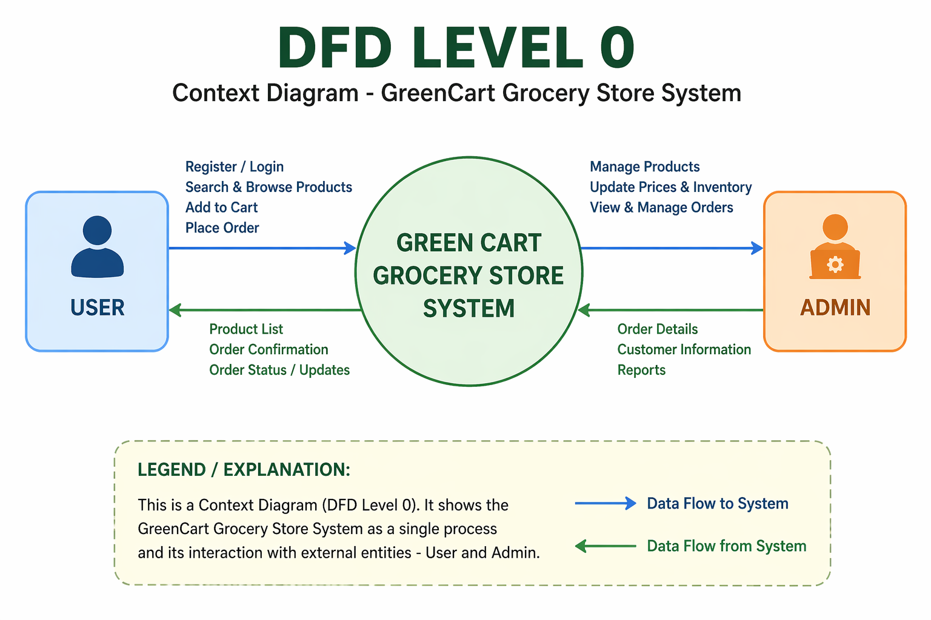

DFD Level 1

🔹 Diagram

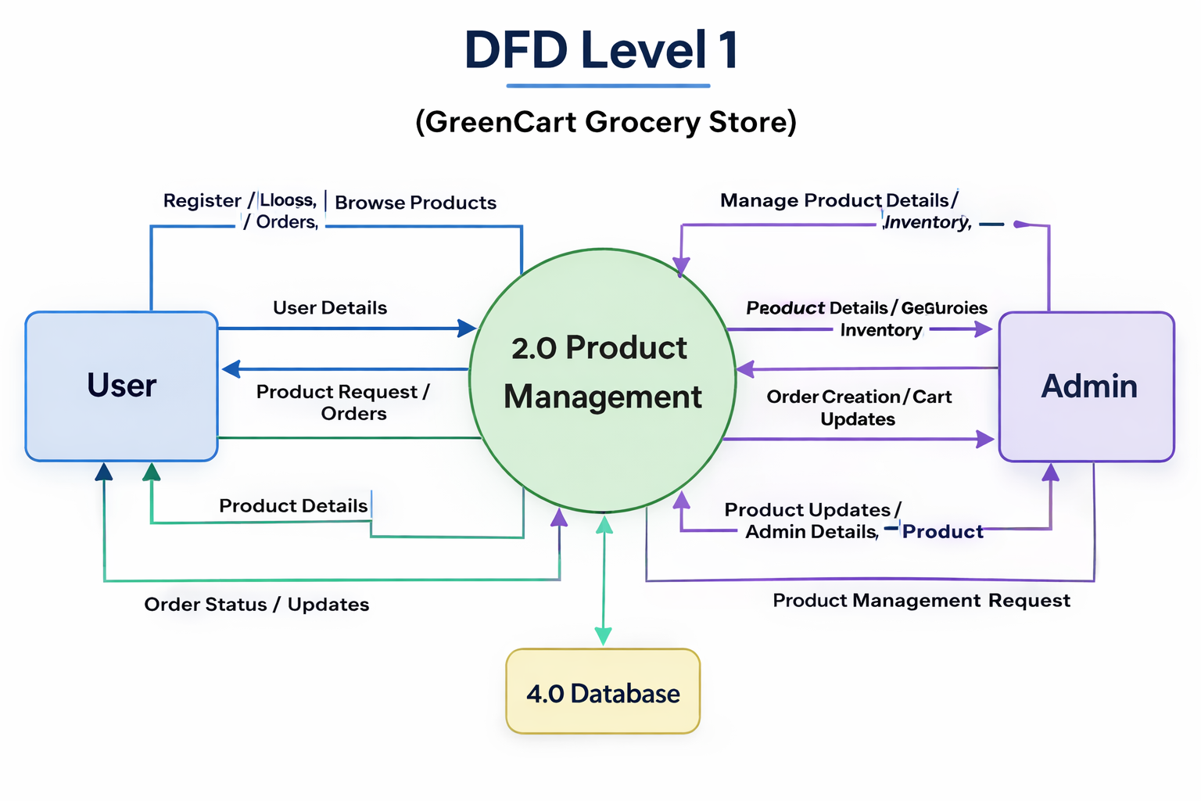

DFD Level 2 :

🔹 Diagram (Cart & Order Example)

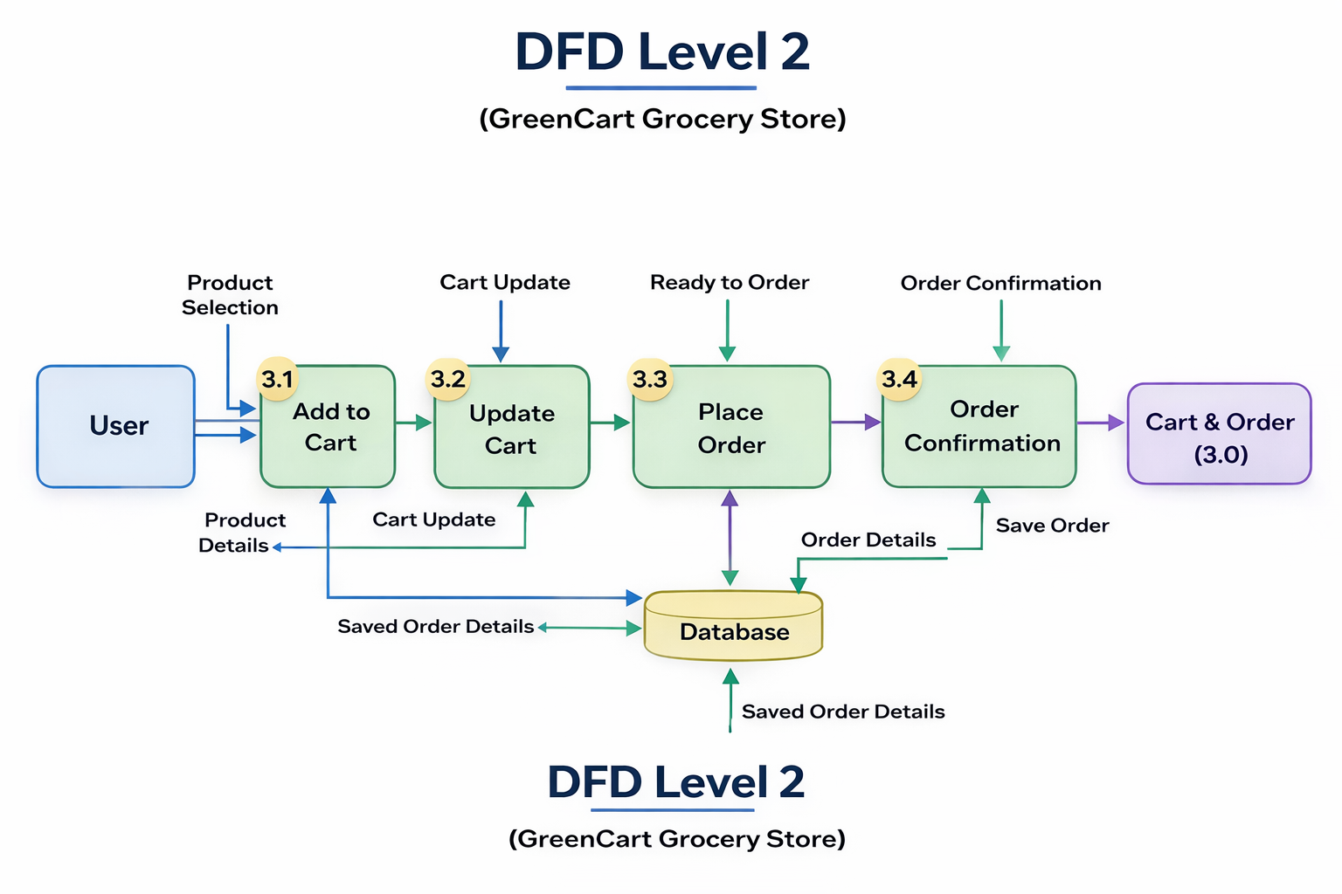

Activity

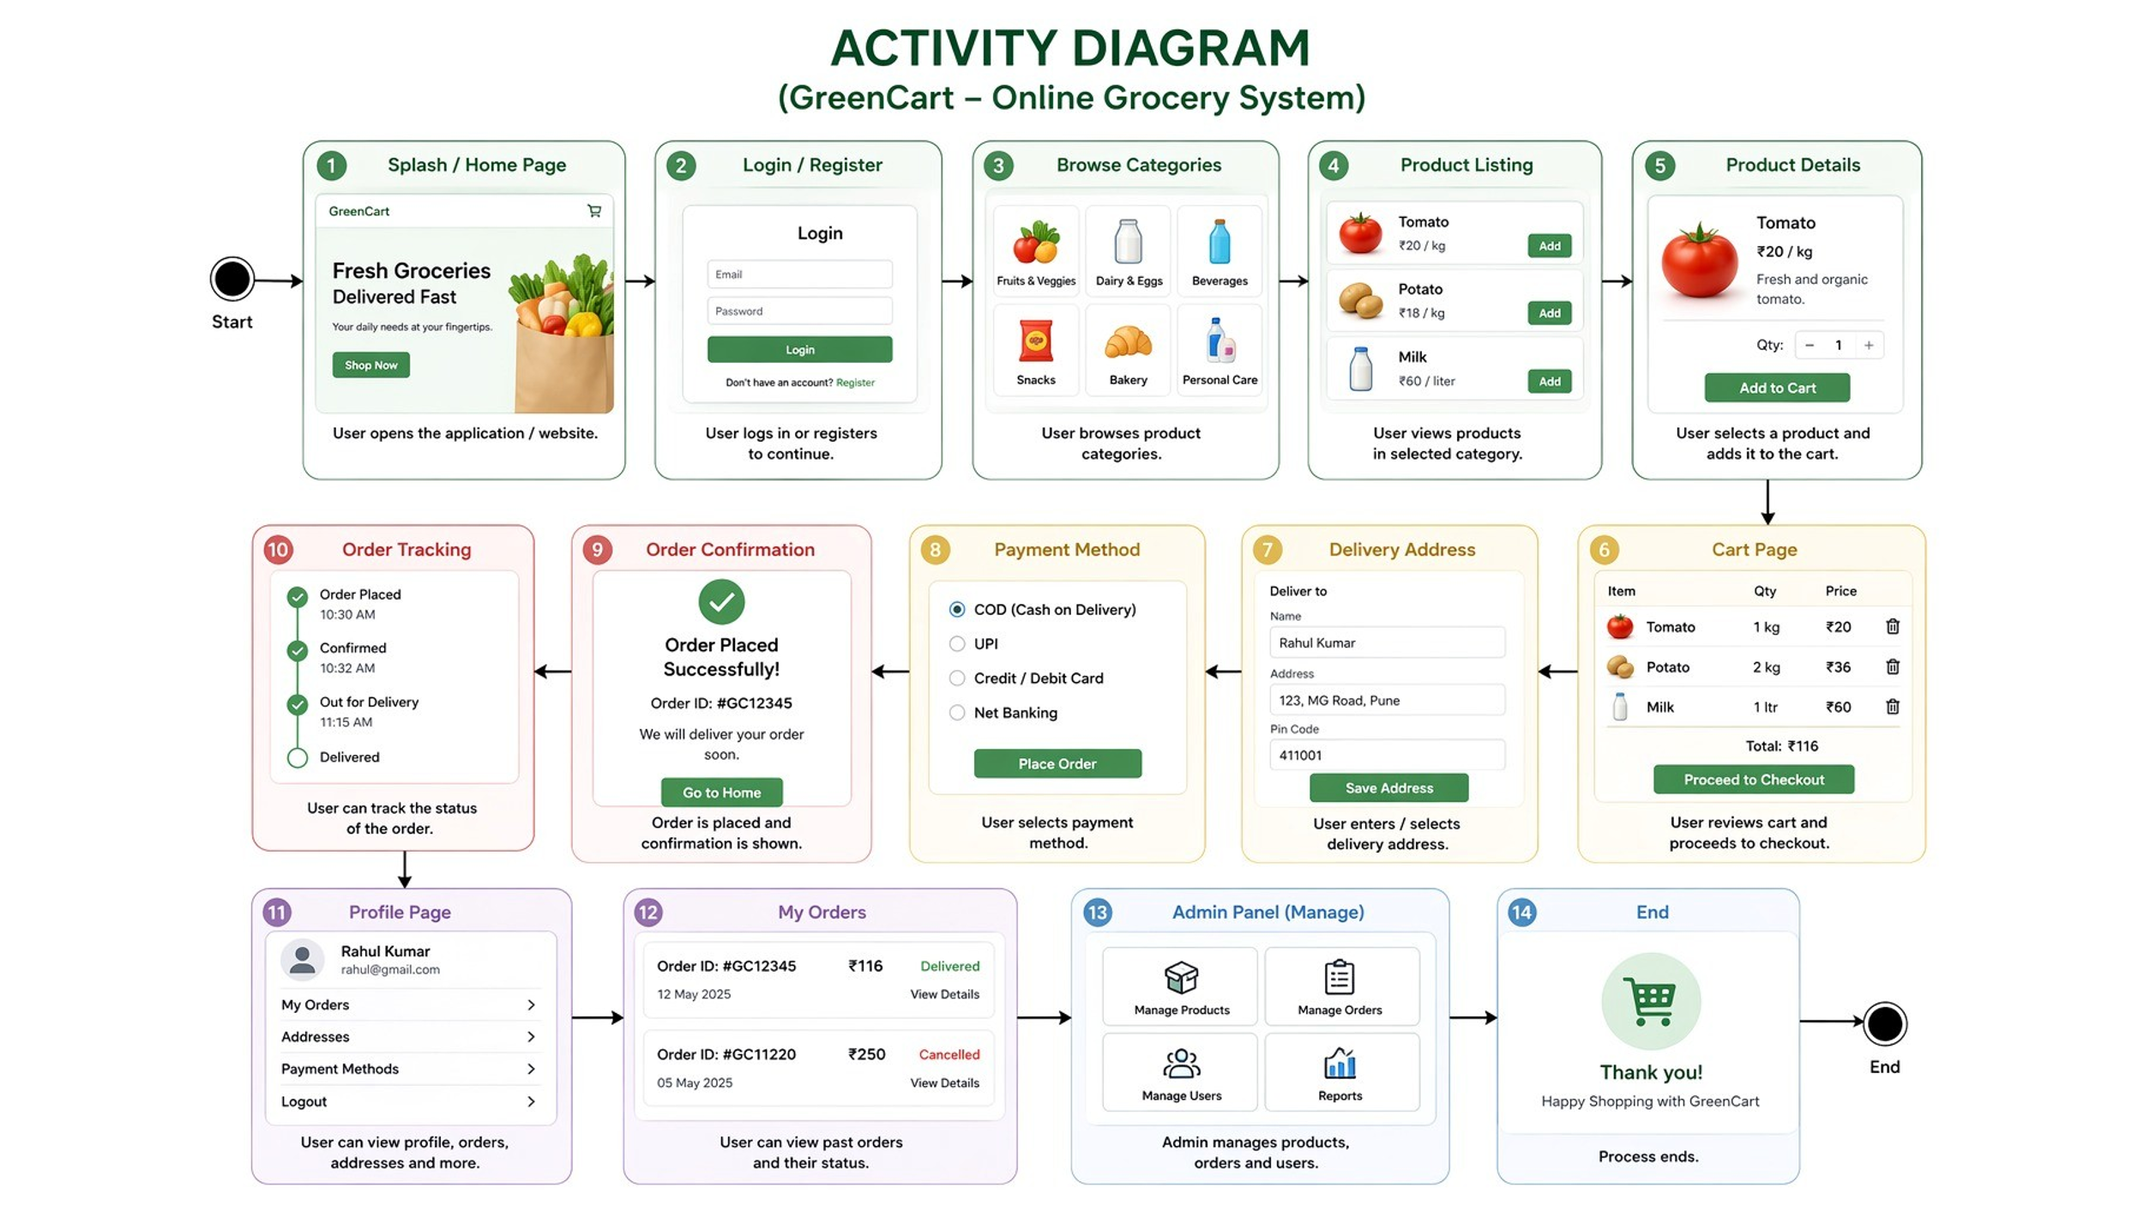

Sequence diagram

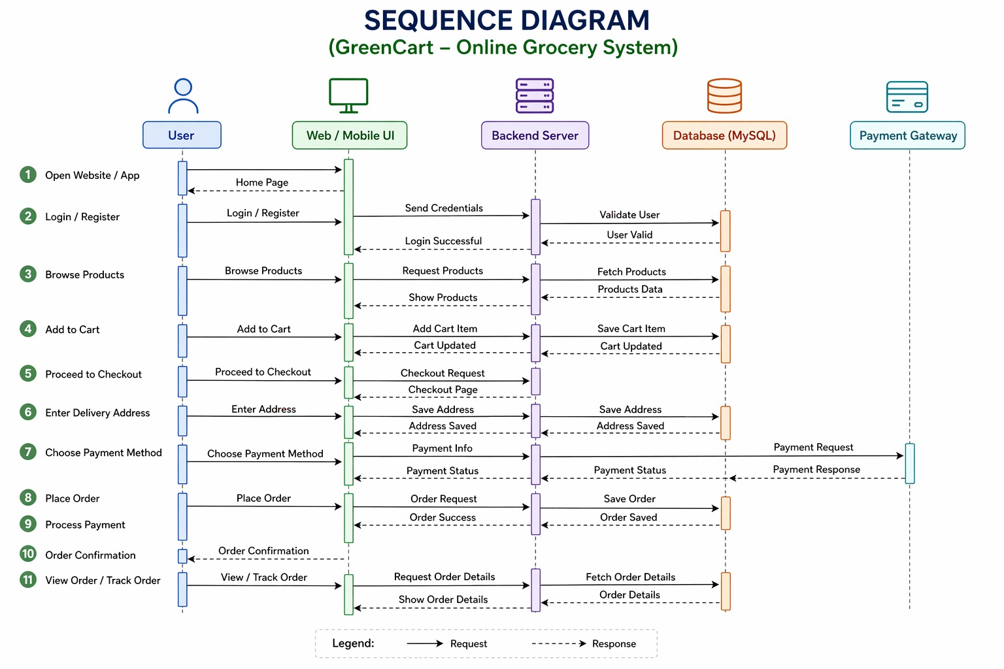

Methodology

The development of the grocery e-commerce website follows a structured approach to ensure efficiency and reliability.
Initially, requirement analysis is performed to understand user needs such as browsing products, adding items to the cart, and placing orders. After that, the system design phase is carried out where the overall architecture, database structure, and user interface are planned.

In the development phase, the frontend is built using React.js, HTML, CSS, and JavaScript, while the backend is developed using Node.js and Express.js. MongoDB is used as the database to store user, product, and order data.

Next, testing is conducted to ensure that all functionalities work correctly and the system is free from errors. Finally, the system is deployed and maintained for future improvements and updates.

Modules Description

1.User Module :

Allows users to register, log in, browse products, search items, add products to the cart, and place orders. It also includes order history and tracking features.

2. Admin Module :

Enables the administrator to manage the system. The admin can add, update, or delete products, manage categories, control inventory, and monitor customer orders.

3. Product Management Module:

Handles product-related operations such as adding new products, updating product details, managing categories, and maintaining product availability.

4. Cart Module:

Manages user-selected items. Users can add, remove, or update product quantities before placing an order. This module ensures smooth checkout functionality.

5. Order Management Module :

Handles order processing, order confirmation, and order tracking. It ensures that all customer orders are properly recorded and managed.

6. Authentication Module:

Provides secure login and registration functionality to protect user data and ensure system security.

Technology Stack :

🔹 Frontend :

The frontend of the application is designed to provide an interactive and user-friendly interface.

- HTML – Used for structuring web pages
- CSS – Used for styling and layout design
- JavaScript – Used for adding interactivity and dynamic behavior

🔹 Backend:

The backend handles the business logic and processes user requests.

- Node.js – Used to build server-side logic and handle requests
- Manages authentication, product operations, and order processing

🔹 Database:

The database is used to store and manage application data securely.

- MySQL – Used as a relational database to store user data, product details, and order information

Implementation

.
🔹 Frontend Implementation:

The frontend is developed using HTML, CSS, and JavaScript to create a responsive and user-friendly interface. Web pages such as the home page, product listing page, cart page, and login/register pages are designed to ensure easy navigation. JavaScript is used to handle user interactions like adding items to the cart, updating quantities, and form validation.

🔹 Backend Implementation:

The backend is implemented using Node.js / PHP to handle server-side operations. It processes user requests such as login authentication, product fetching, cart management, and order placement. The backend also ensures proper communication between the frontend and the database.

🔹 Database Implementation:

A MySQL database is used to store all the necessary data, including user details, product information, cart items, and order records. Tables are created with proper relationships using primary and foreign keys to maintain data integrity.

🔹 Modules Implementation:

- User Module: Handles user registration, login, and profile management
- Product Module: Displays products and manages product data
- Cart Module: Allows users to add, update, or remove items
- Order Module: Processes orders and stores order details
- Admin Module: Enables admin to manage products and orders

🔹 System Integration:

All components (frontend, backend, and database) are integrated to work together seamlessly. When a user performs an action (like placing an order), the request is sent to the backend, processed, stored in the database, and the response is displayed on the frontend.

The expected outcome of the proposed GreenCart Grocery E-commerce Website is to develop a fully functional and user-friendly online shopping system that improves the traditional grocery shopping experience.
After completing this project, the system will be able to:
- Provide users with an easy-to-use platform for browsing and purchasing grocery products online.
- Allow customers to register, log in, and manage their personal accounts securely.
- Enable smooth product searching, selection, and addition to the shopping cart.
- Support secure and efficient order placement and checkout process.
- Provide an admin panel to manage products, categories, orders, and users.
- Reduce manual work and time required for physical shopping.
- Improve accessibility by allowing users to shop from anywhere at any time.
- Ensure faster and more convenient grocery delivery process (if delivery module is included).
- Maintain proper database management for products, users, and orders.

Screenshots

1.home page

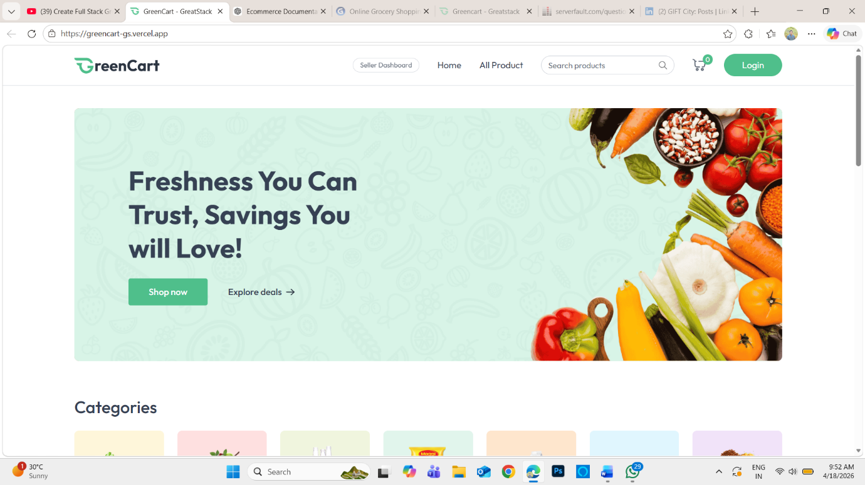

The home page of the grocery e-commerce website is designed to provide a clean and user-friendly interface. It includes a navigation bar with options such as Home, Products, Cart, and Login/Signup. The page displays featured products, categories, and special offers to attract users. A search bar is provided to quickly find grocery items. The layout is responsive and visually appealing, ensuring smooth user interaction across devices

- Navigation bar (Home, Products, Cart, Login)
- Banner / Offers section
- Product listing (cards with image, price, add to cart)
- Search functionality
- Responsive UI design

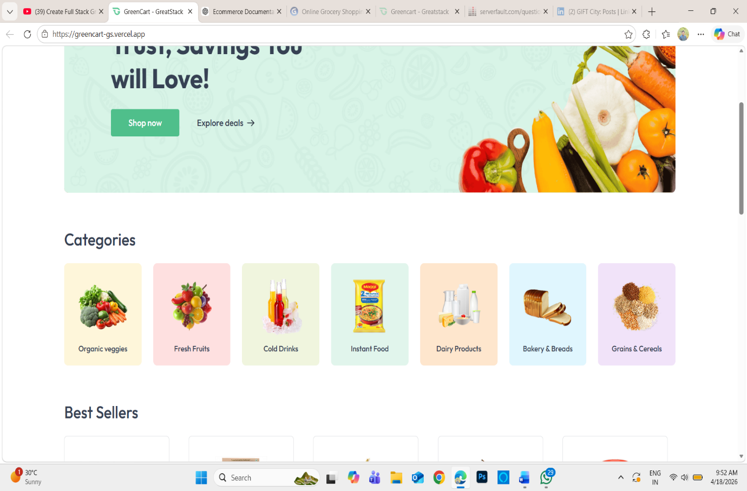

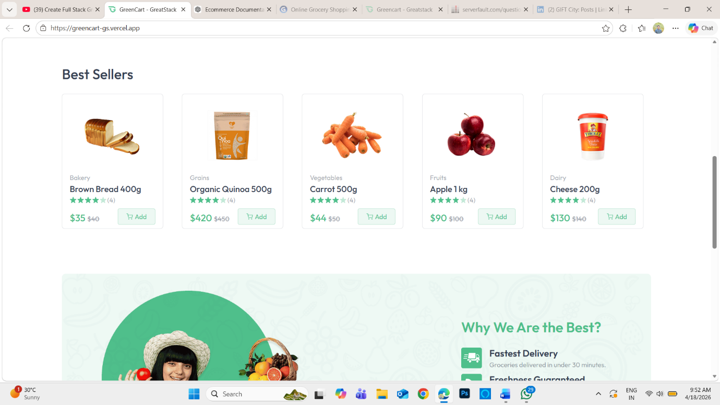

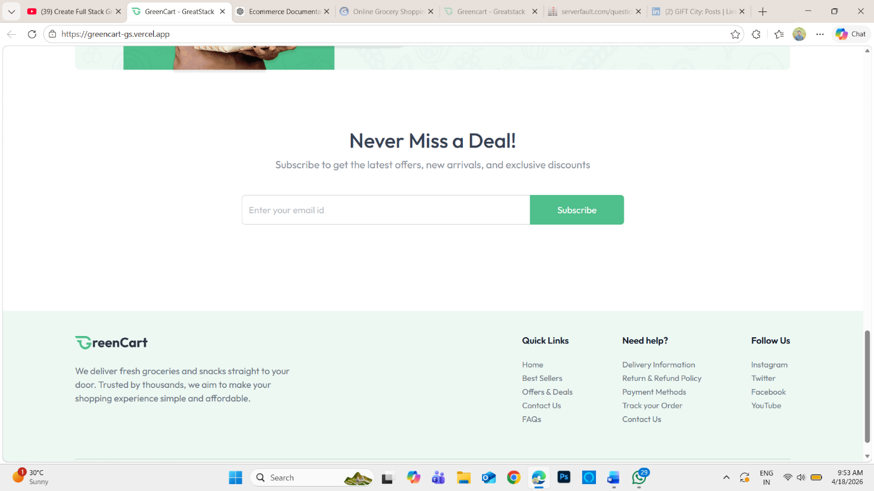

The home page of the grocery e-commerce website is designed to provide a clean and user-friendly interface. It includes a navigation bar with options such as Home, Products, Cart, and Login/Signup. The page displays featured products, categories, and special offers to attract users. A search bar is provided to quickly find grocery items. The layout is responsive and visually appealing, ensuring smooth user interaction across devices

- Navigation bar (Home, Products, Cart, Login)
- Banner / Offers section
- Product listing (cards with image, price, add to cart)
- Search functionality
- Responsive UI design

1.loging page

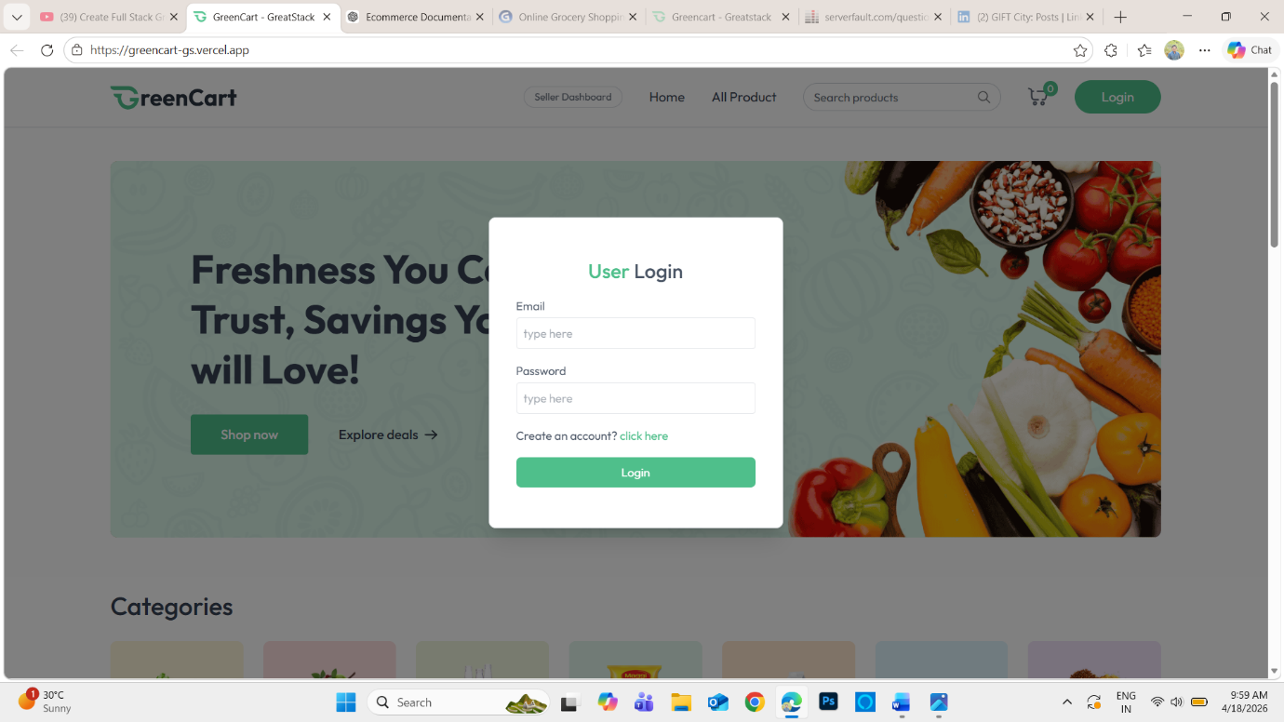

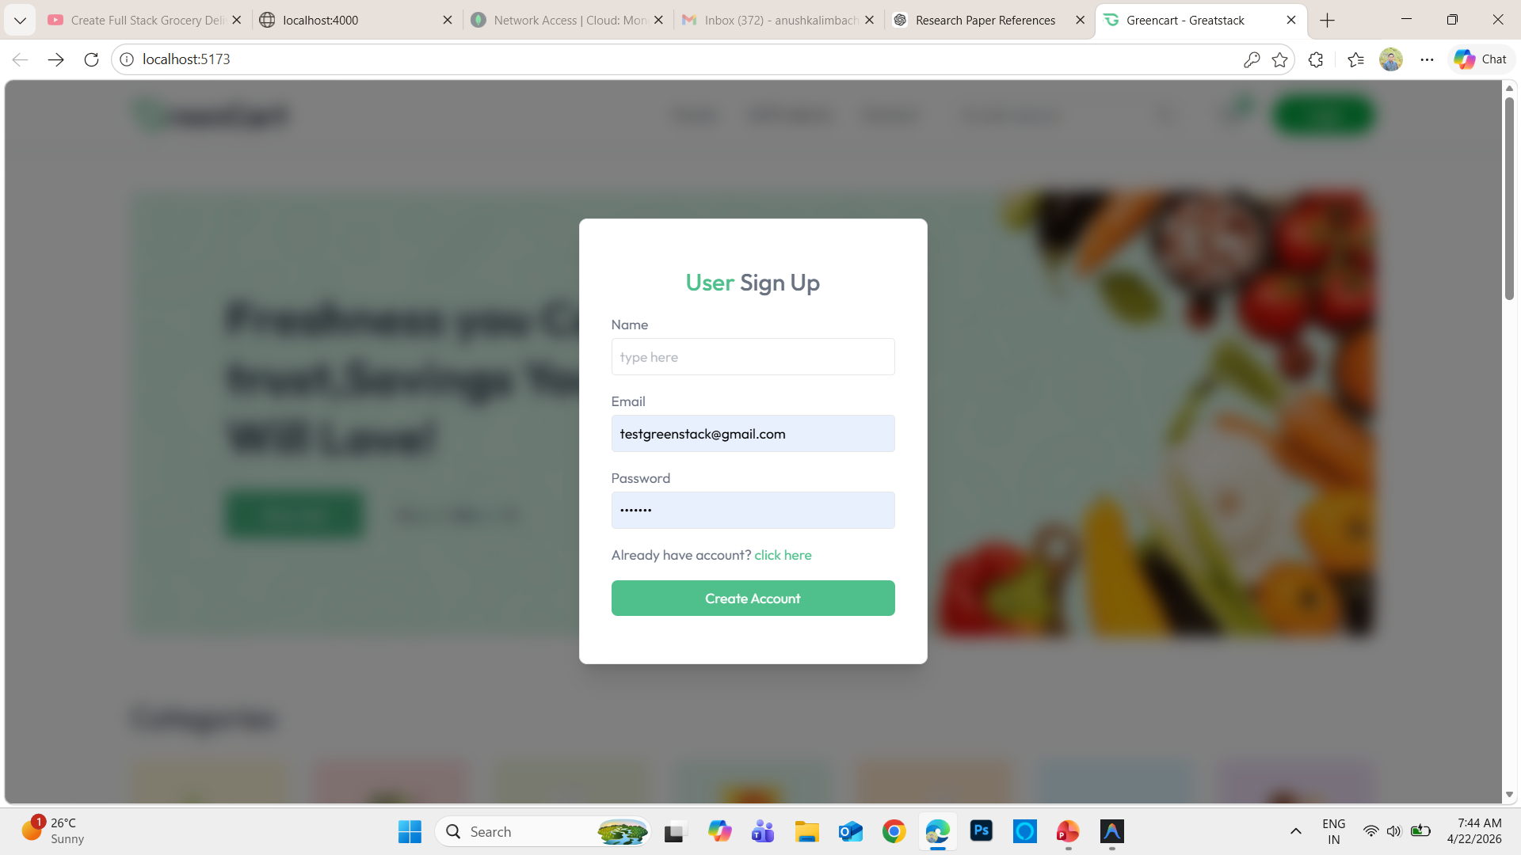

The login functionality is implemented using React.js on the frontend and Node.js with Express.js on the backend. User credentials are sent securely through API requests and verified using the backend server. Passwords are stored in encrypted format (using hashing), and authentication is managed to allow only valid users to access the system

- Email/Username input field
- Password input field
- Login button
- Signup / Register option
- Form validation (required fields)
- Secure authentication

2. all product

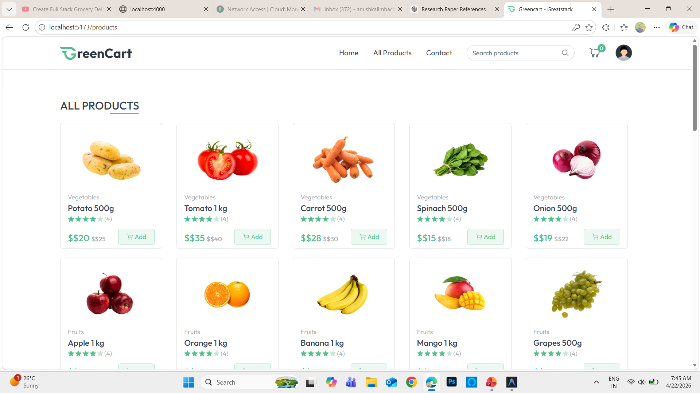

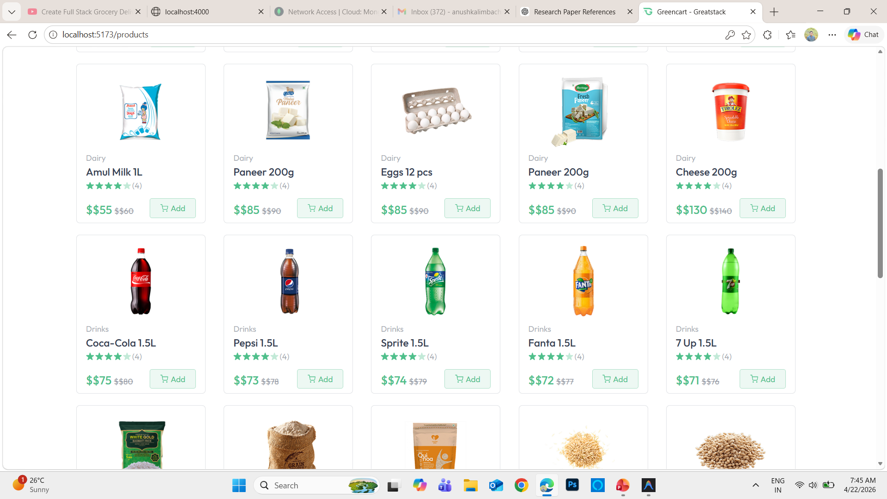

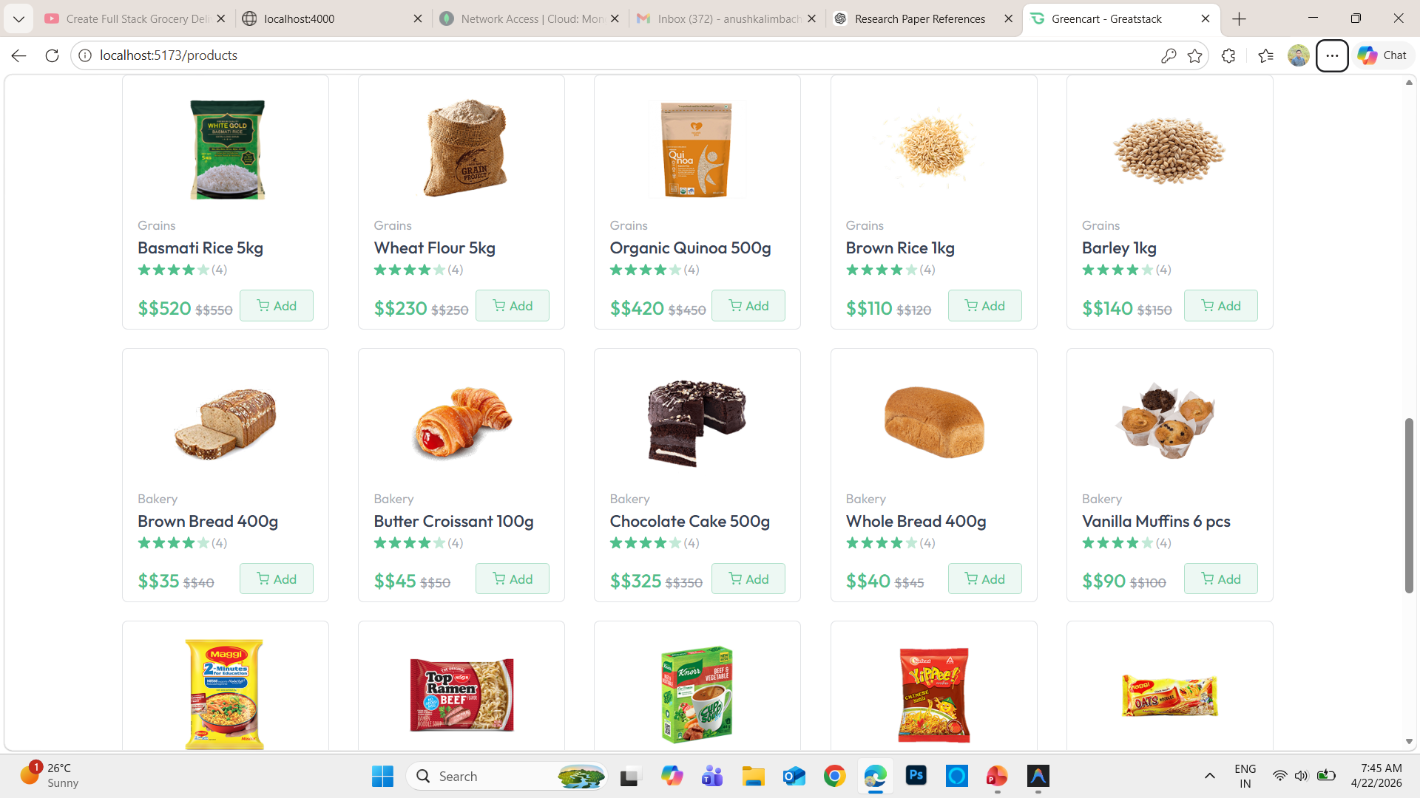

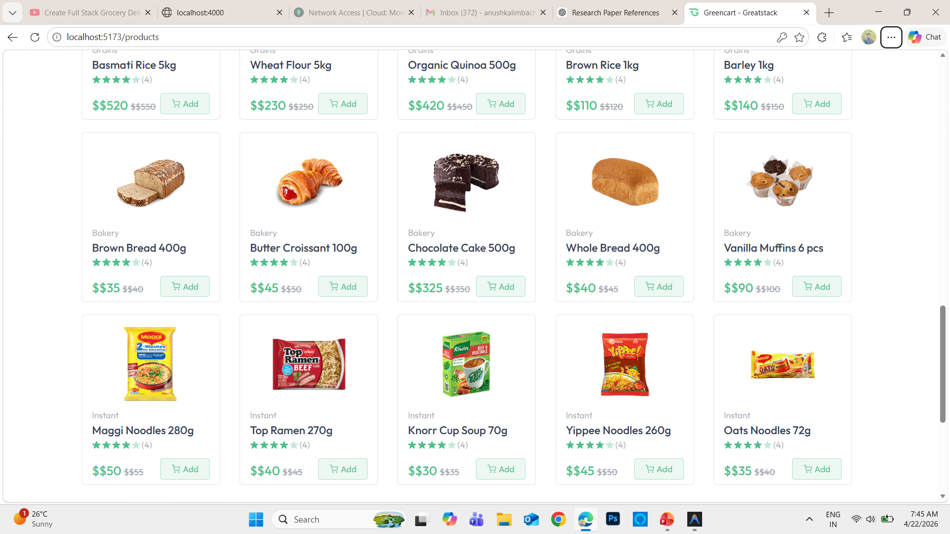

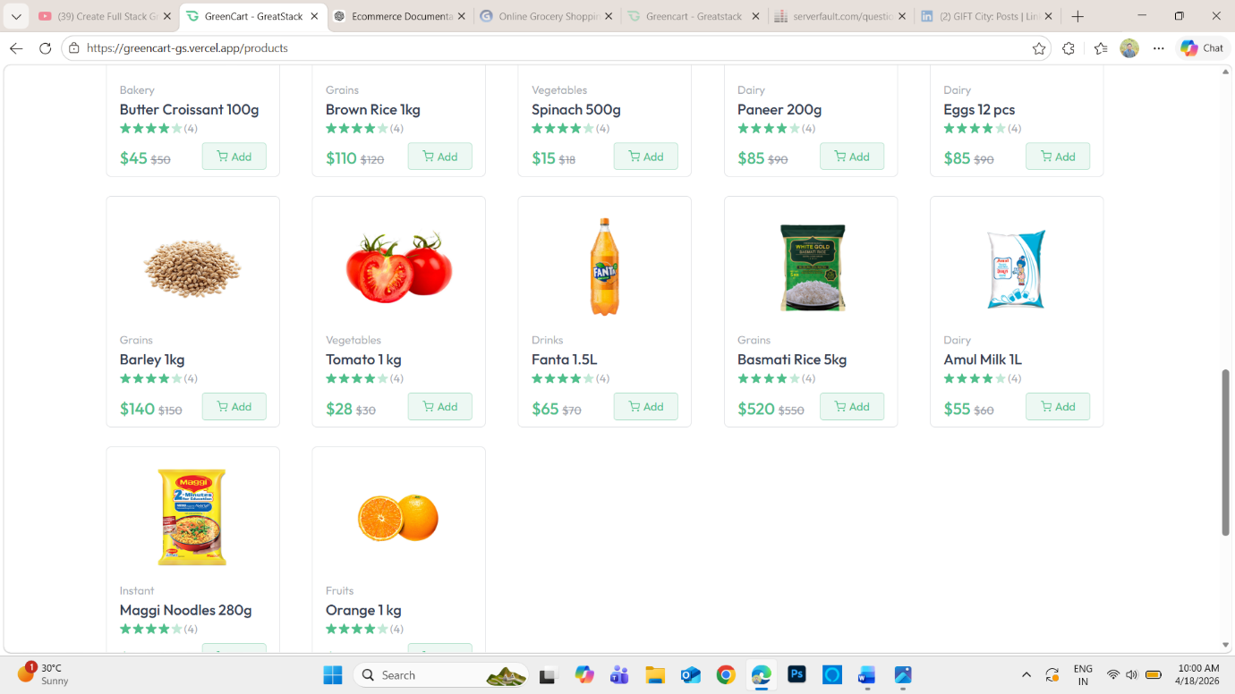

The All Products page is developed using React.js, where product data is fetched from the backend using API calls. The backend built with Node.js and Express.js retrieves product data from the MongoDB database and sends it in JSON format. The frontend dynamically renders the products using components and manages state for search, filters, and cart actions.

- Product cards (image, name, price)
- Add to Cart button
- Search bar
- Filter / category options
- Responsive grid layout
- Dynamic data loading from backend

3.oder product

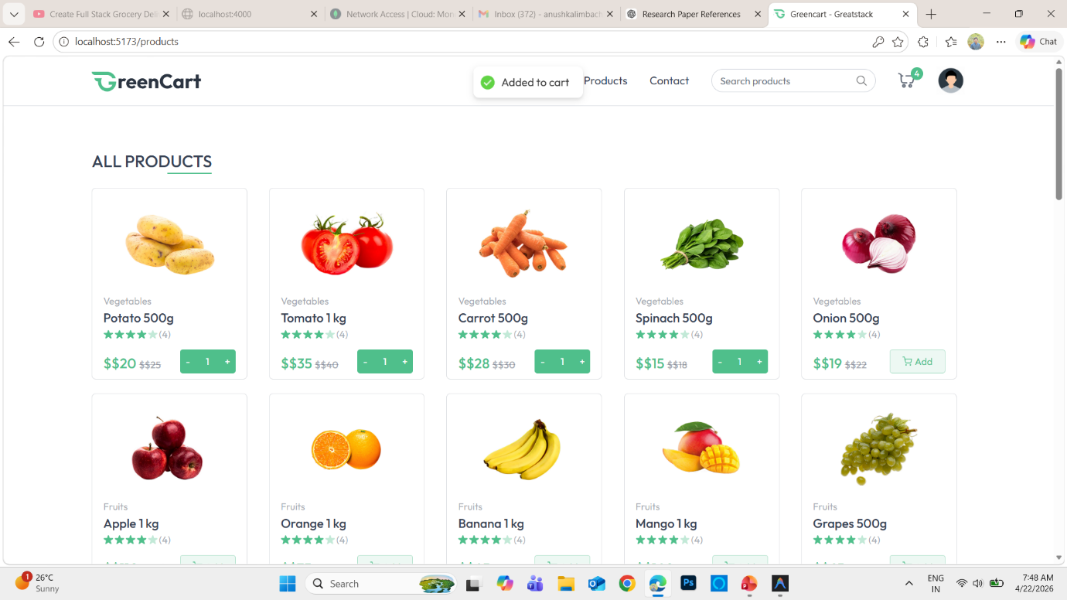

Select Product (Detailed Explanation)
After logging into the system and browsing the available products, the user selects a specific product to view more details before purchasing.

Process:
- The user clicks on a product from the product listing page or search results.
- The system redirects the user to the Product Detail Page.
- This page displays complete information about the selected product, such as:
  - Product name
  - Product image
  - Price
  - Description
  - Available stock
  - Ratings or reviews (if available)

User Actions:
- The user can carefully read the product description to understand its features.
- The user can select required options like:
  - Quantity
  - Size / Color / Variant (if applicable)
- The user can compare the product with other similar items if needed.
System Response:
- The system checks product availability in real-time.
- If the product is in stock, it allows the user to proceed further.
- If the product is out of stock, the system shows an appropriate message.

Outcome:
After reviewing and selecting the required options, the user can either:
- Click “Add to Cart” to continue shopping, or
- Proceed directly to purchase if the option is available.

4.shopping cart

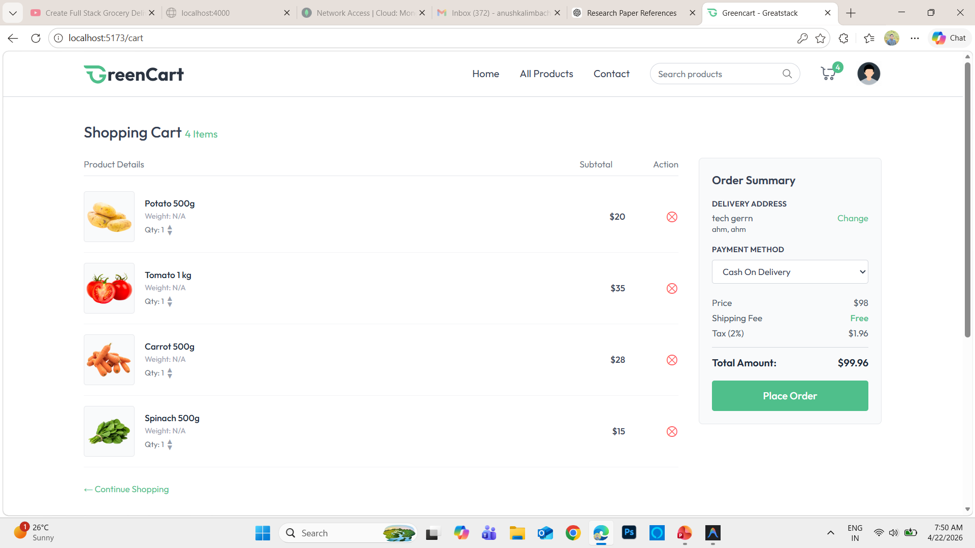

Add to Cart Functionality

The Add to Cart feature is implemented using React.js on the frontend. When the button is clicked, the product data is stored in the application state (using Context API or Redux) or sent to the backend.
The backend built with Node.js and Express.js processes the request and stores cart data in MongoDB (or session/local storage if temporary). The system updates the cart count and total price dynamically

- Add to Cart button action
- Product added with quantity
- Cart icon updates (count)
- Data stored (state/database)
- Real-time price calculation

5. address

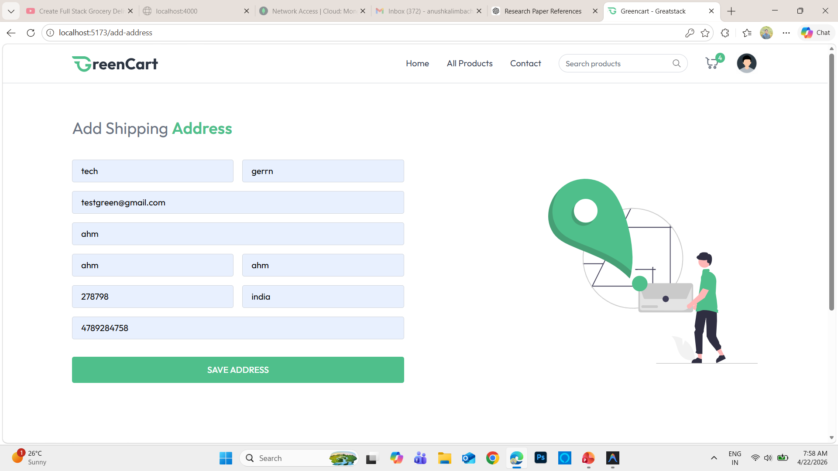

Add / Change Address

This feature is implemented using React.js for the frontend form. When the user submits or updates the address, the data is sent to the backend using API calls. The backend built with Node.js and Express.js processes the request and stores or updates the address in the MongoDB database linked to the user account.

- Address input form (name, phone, address, city, pincode)
- Add / Edit / Save button
- Validation (required fields)
- Data stored in database
- Used during checkout

6. place oder

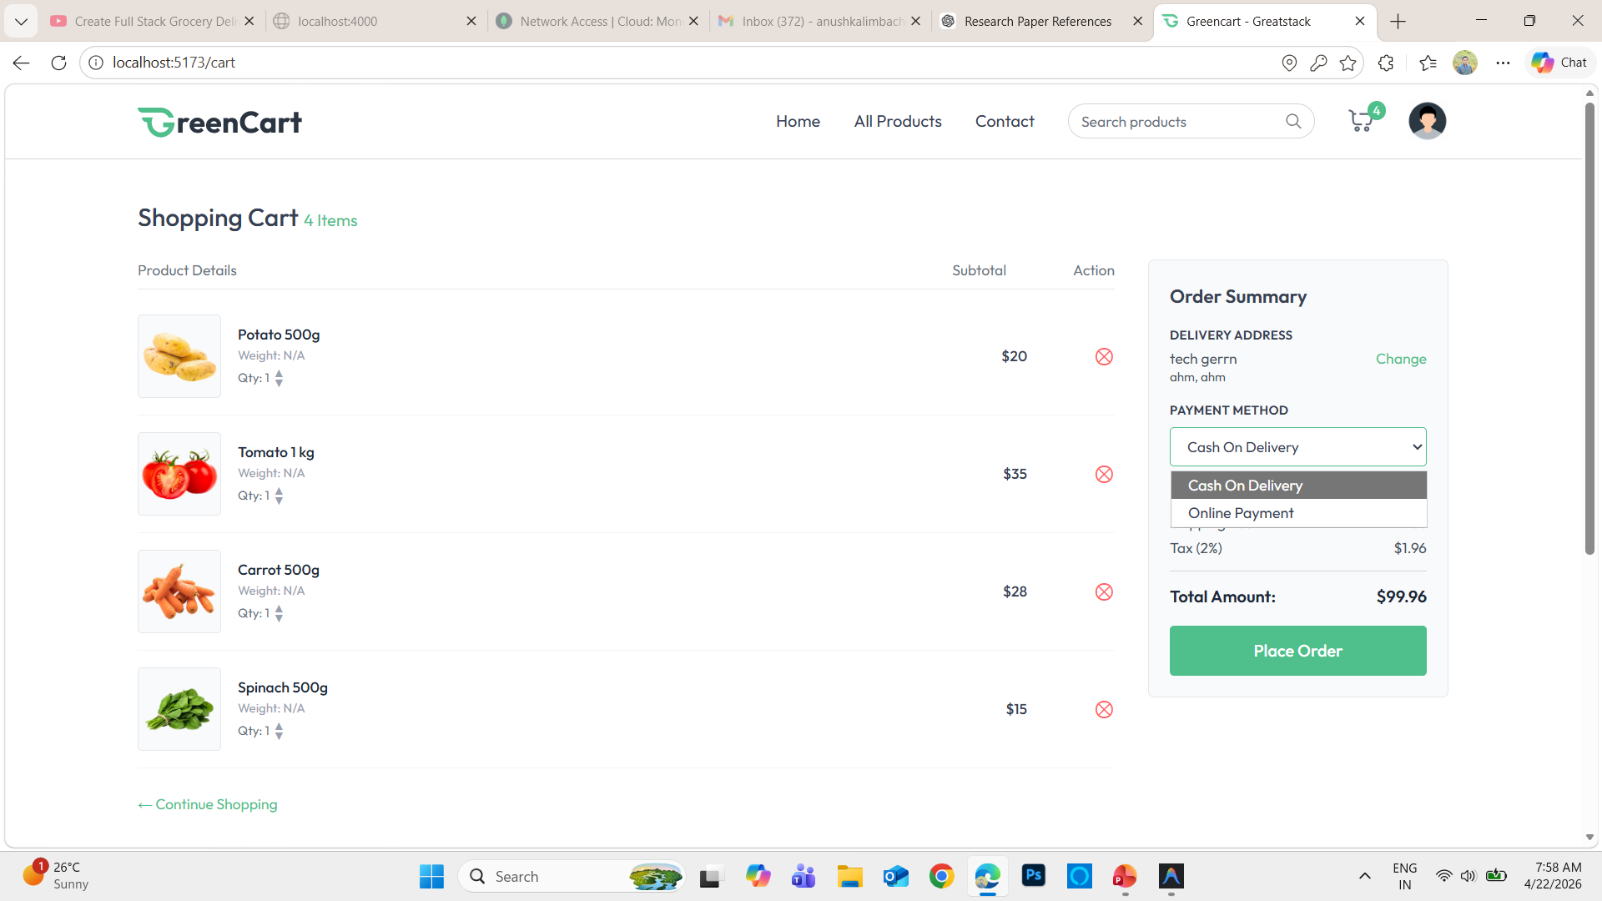

The Shopping Cart is an essential module in an e-commerce system that allows users to temporarily store selected products before completing the purchase. It works like a virtual basket where users can add, update, or remove items before checkout
1. Add Products to Cart
When a user selects a product and clicks on the “Add to Cart” button, the product is stored in the shopping cart. The system keeps track of selected items using a session or database.

2. View Cart
The user can view all selected products by opening the cart page. It displays:
- Product name
- Product image
- Price
- Quantity
- Total cost of each item

3. Update Cart
The shopping cart allows users to modify selected items before placing the order. Users can:
- Increase or decrease product quantity
- Remove unwanted products from the cart
The system automatically updates the total amount after every change.

4. Calculate Total Amount
The system calculates the final payable amount, which includes:
- Subtotal (price × quantity)
- Taxes (if applicable)
- Delivery charges (if applicable)
The final total amount is displayed clearly to the user.

5. Proceed to Checkout
After reviewing the cart, the user clicks on the “Checkout” button to continue the purchasing process. The cart details are then sent to the order processing module

7.my oder

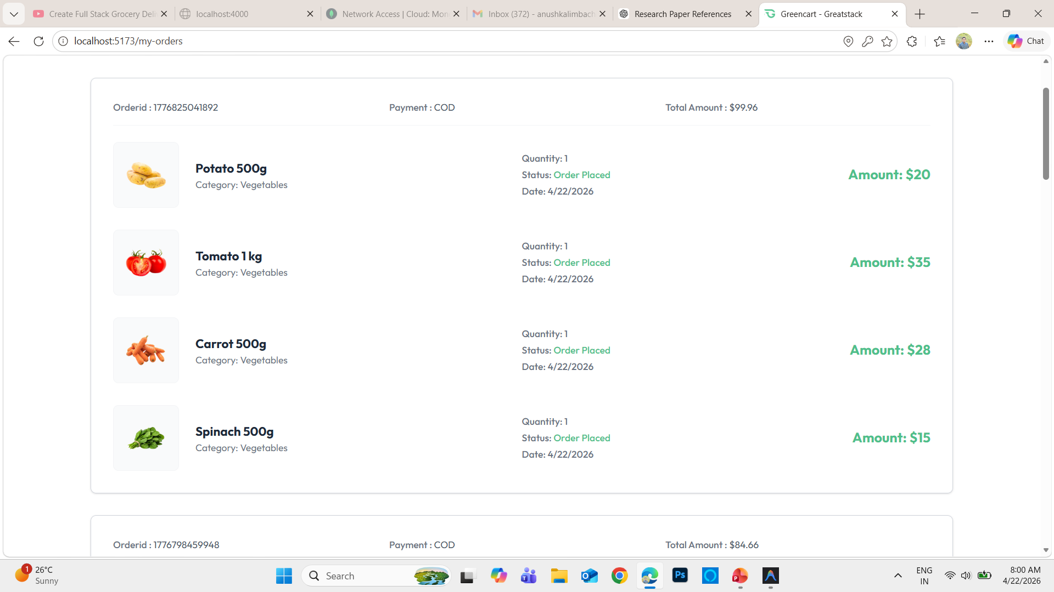

The Place Order functionality is implemented using React.js on the frontend. When the user clicks the button, all order details (products, quantity, total price, and address) are sent to the backend via API.
The backend built with Node.js and Express.js processes the order, verifies the data, and stores it in the MongoDB database. It also updates product stock (if implemented) and generates an order ID.

- Order summary (products, total price)
- Selected delivery address
- Place Order button
- Order confirmation message
- Order ID generation

8.logout

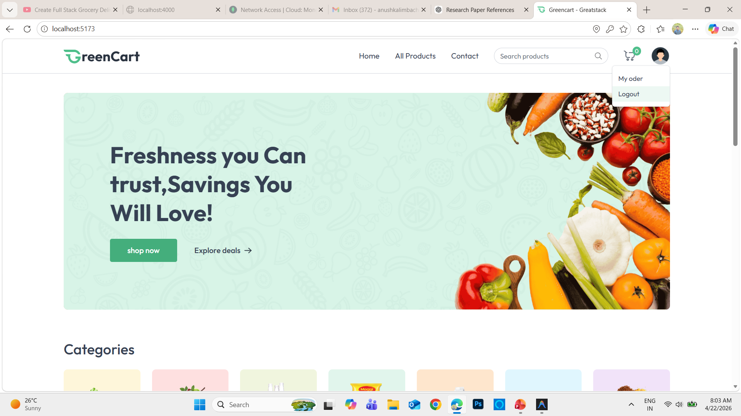

1. User Action
When the user finishes browsing or placing an order, they click on the “Logout” button available on the website.

2. Session Termination
The system immediately ends the user’s active session. All temporary session data is cleared from the server or browser.

3. Security Update
After logout, the system ensures that the user account is no longer accessible without login credentials. This helps maintain account security.

4. Redirect to Login/Home Page
Once logout is successful, the user is redirected to the login page or homepage of the website.

admin panale screenshots

